**Student ID: IT24102836**

**Module Code: IT2120**

**Lab Sheet: 10**

**Exercise**

1. A vending machine owner claims that customers choose the four snack types (A, B, C, D) with equal probability. To test this claim, a researcher records the number of purchases for each snack type during one week and results are given below.

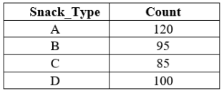

i. State the null and alternative hypotheses for the test.

Null hypotheses: The probability that customer chooses one of each of the four snack types will be 0.25.

Alternative hypotheses: At least one snack will have a probability of being chosen by the customer different from 0.25.

ii. Perform a suitable chi-squared test to test the null hypothesis.

iii. Give your conclusions based on the results.

Since the p-value is 0.08966, which is greater than 5% (0.05) of significance, we can conclude that the probability of customers choosing one of four snacks will be the same which is 0.25.